SPACE GNOME

Art Design Document

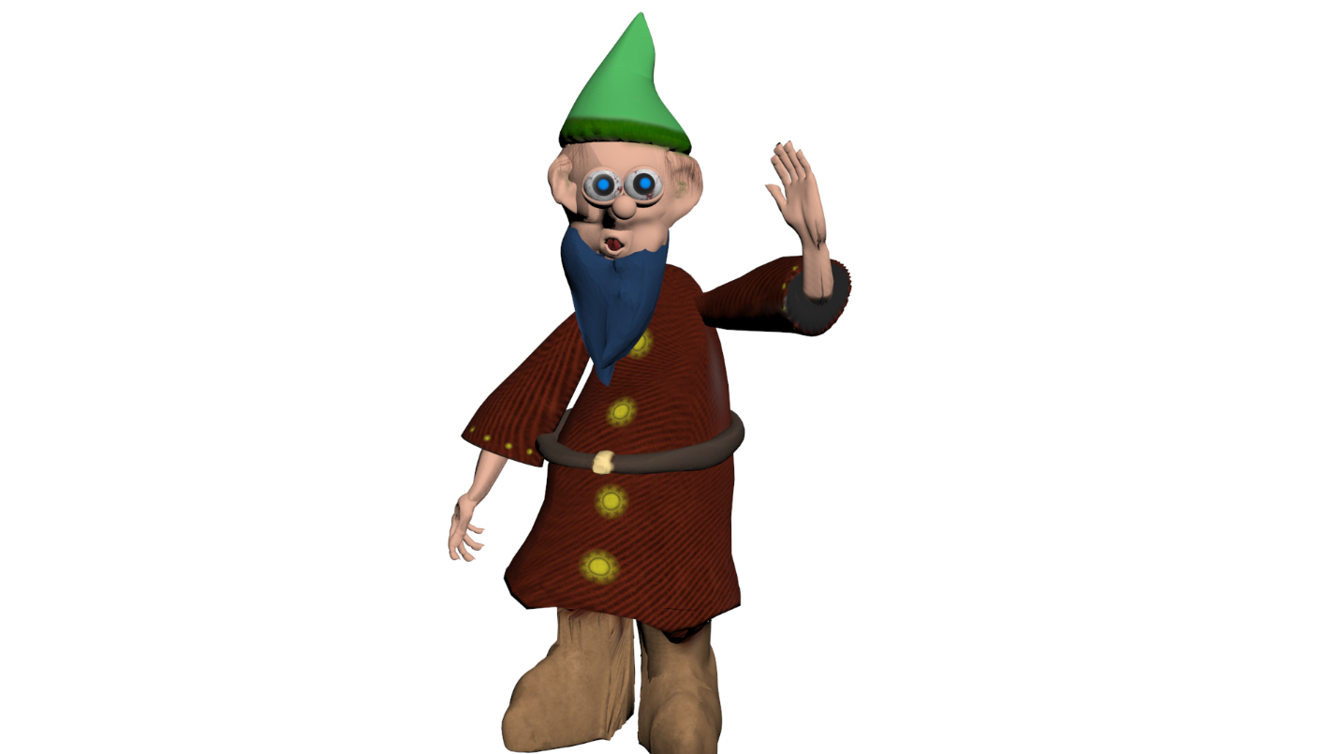

Version: 0.4
Document Created: January 07, 2020 by Tim
Last Revised May 23rd, 2020 by Tim
Document Purpose
Summarize and provide reference and inspiration for the creation of art assets and art design in the game.
Game Summary
- Space Gnome is about a Gnome exploring our solar system. He must use his cunning to find planets to explore, and his acrobatic skills to gain entry from space to the planet’s surface, in style.
- The art direction is perhaps the most unique aspect of the game, exploring the wacky and irreverent world of an intrepid and curious gnome, in space. Some games that Space Gnome takes inspiration from are the Tony Hawk: Pro Skater series and space exploration games like Elite Dangerous.
- Surreal, Irreverent, Funny art style. Think Salvador Dali meets Mark Tansey.
The Persistence of Memory, Salvador Dali, 1931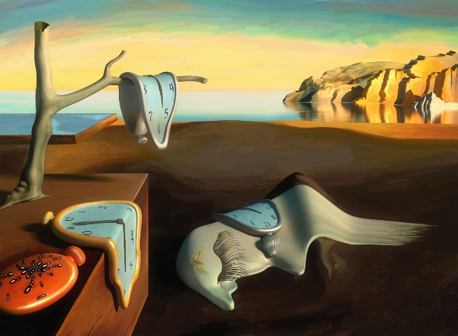
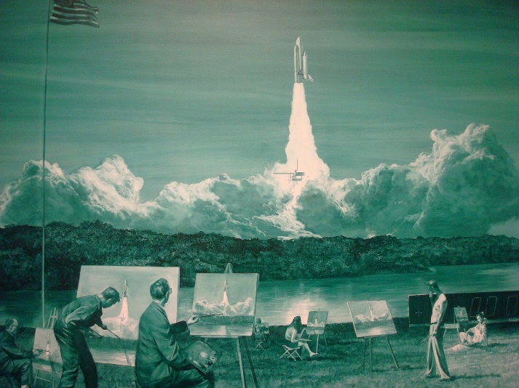Action Painting II, Mark Tansey, 1984

Theme and Setting:
- Theme:
  - Individual curiosity and movement’s role in creating happiness.

- Setting:
  - As already mentioned, Space Gnome takes place in space. In terms of its temporal setting, it takes place in modern day, and mixes the fantastical (gnomes, etc.) with the realistic. At the outset of the story, our hero, recently retired, decides to steal the Space Shuttle Endeavour after reading about its decommission, and take it on a joyride that leads to an epic adventure.

Core Gameplay Loop

Finish Story

Art Style
As mentioned above the game’s art style will blend the familiar modern day aesthetics of urban environments, space, science and technology with the fantastical, surreal, and even absurd. The artists should keep their tongues firmly planted in their cheeks, keep the tone light and comedic, and focus on having fun while making assets, as that comes through in the finished work.

Engine
We will be using Unity 3D for our game, in 3d mode, and most assets will also be in three dimensions. Since Space Gnome takes place in space, and the play spaces are quite vast, a challenge for the artists will be to keep objects close enough to be visible, without seeming crowded. We want to create a feeling of endless expanse in most if not all levels.
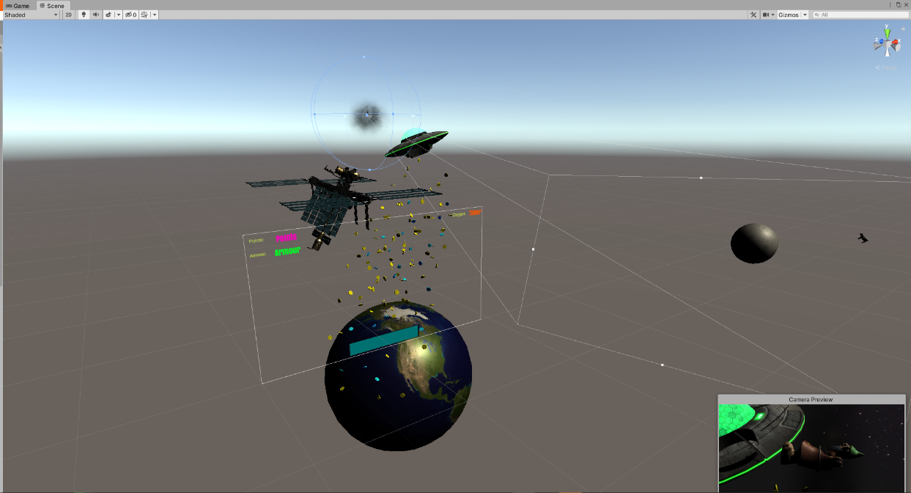
We will also be making heavy use of Unity’s animator component, as a lot of the focus in Space Gnome is on character movement through space.
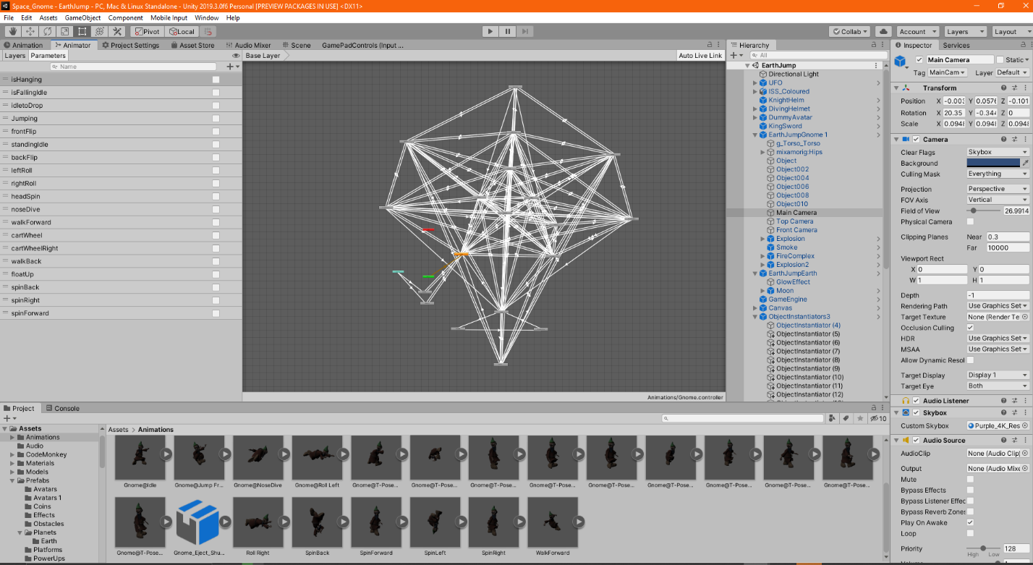
Parameters

Scale and Size:

Since we are dealing with asteroids, space stations, and various celestial bodies we will be working on a fairly large scale. However, for the sake of expediency in terms of the creation of assets we will not be working at a realistic scale. Everything should be relative to the size of the Player, which will be roughly 1 meter cubed.

Naming Conventions:

- Files should use full names of objects that describe in obvious terminology what the asset is.
- Texture materials should be renamed in 3dsMax to correspond to the object they will be applied to.
- Multiple assets of the same type should be numbered with an underscore and then two digits (eg. PlayerIdleAnimation_02).

File Formats:
For textures, all files should be in 1:1 pixel ratio (square) 16 Bit 72 colour .pngs. The default size for textures should be 512x512, though higher resolution textures are acceptable, or even preferred, for certain assets that will be highly and regularly visible to the player (eg. Character, Space Shuttle, Planets—these will be 8k textures, and objects that are re-used regularly [eg. Power ups, obstacles, etc.]).
For models, all files will be created in 3dsMax and exported to .fbx format for importing into Unity.

Version Control: In addition to built in revision history in the version control software we are using, all changes to art assets should be accompanied by a short entry in the Revision History spreadsheet, including author, time, and short description of changes made.
Art Asset Checklist:
A comprehensive table containing an entry for every art asset necessary will include file type, file size, and other relevant information.
Concept Art

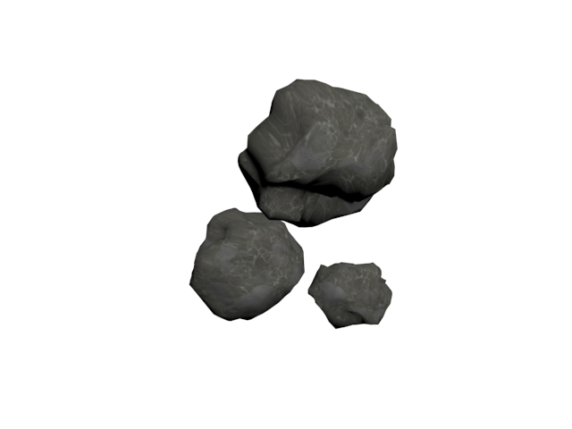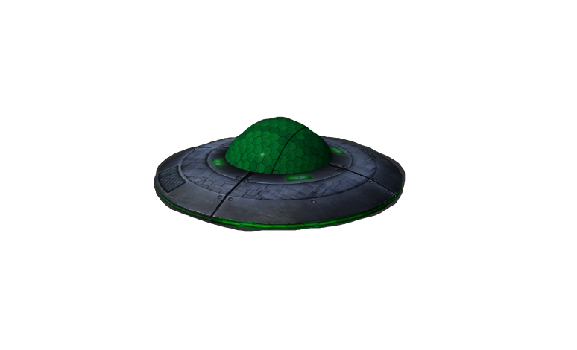
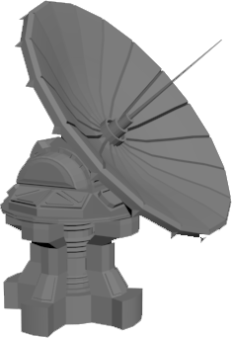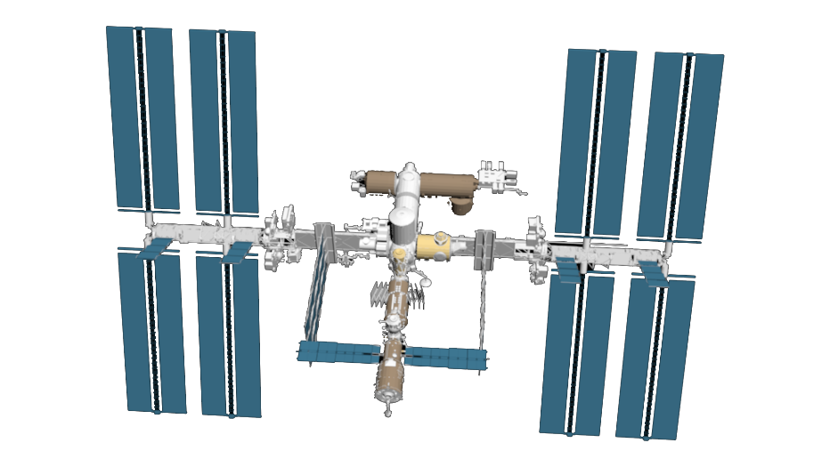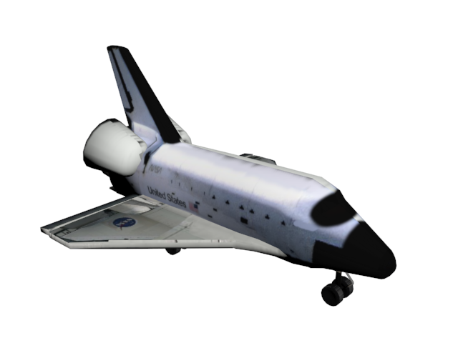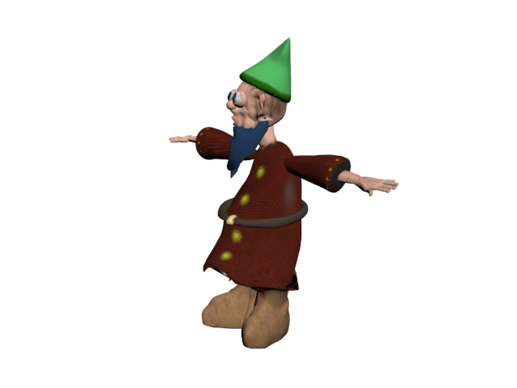

Colour Schemes
We will use different colour palettes for different parts of the game.
For the environment, background, and non-interactable objects we will use dark colours, mostly black with some bright contrasting colours for stars, planets, gases, etc.

For the interactable/consumable objects and prompts in the game we will use bright primary colours combined with some pastel tones so that is obvious to the player that they have functionality. A challenge will be having the colours of interactable objects not clash with other palettes.

For the player object we will use fairly soft neutral earth tones, in brighter shades than the environment palette. We want the player object to stand out clearly against the environment, but as the Player will focus on this object the most we don’t want it to be too harsh to look at continuously.

Interactable objects colour schemes will vary widely, as will obstacles.

Models
- All models should be a maximum of 10MB in the .fbx file format and include polygon counts in the art asset checklist spreadsheet.

- All models should have a corresponding .UVW file as well as a UV template for potential refinement. File names should match the corresponding file name of the model with the suffix “_UV” or “__UV_template”.

- All models should fit into one of the following categories:

- Player
- Obstacles
- Interactable Objects
- PowerUps
- UI
- Cut Scenes
- Animations
Textures

- All texture files should be square regardless of their resolution (512x512, 1024x24, etc.)
- All texture files should be in 16Bit and 72 RGB colour.
- Texture files should be stored in the appropriate folder with a descriptive name in the projects Assets/Textures folder.
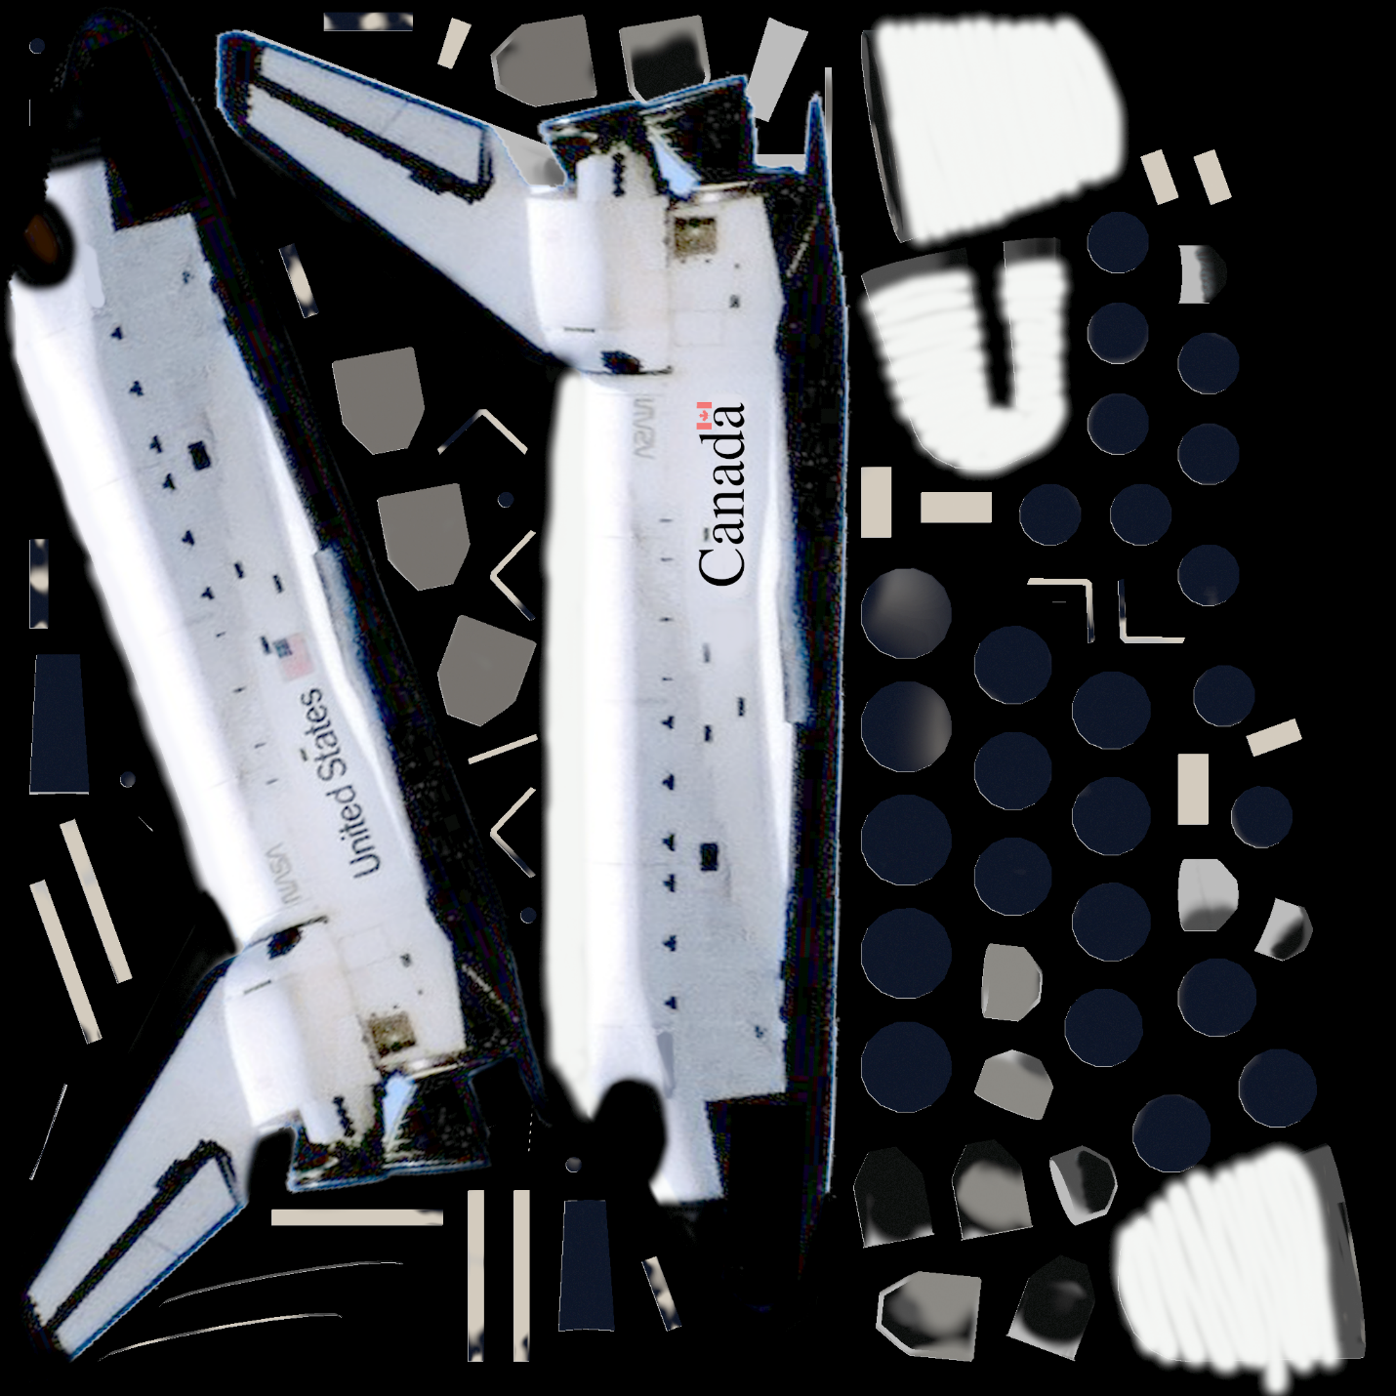
Animations
Animations should be relatively simple, not overly complex and detailed in order to maintain the cartoonish style of the game and facilitate production of as many of them as possible in the short production window we are working in.
We will need animations for each gnome dance move and basic movement, as well as nose diving and floating up. Also charging animations to transition between moves, for a total of 23 animations, most of which transition to each other. We will be using Unity’s animation system.

Particle Effects
We will make use of the Particle Effects in the Unity standard assets package as well as custom made effects. We may use a shader graph in the future, or volumetric clouds to separate each zone in the level, but for the time being we will rely on particle effects to delineate the separation between zones. There will also be several particle effects on the gnome himself. Speed lines for when he’s nose diving, flame and smoke for when he’s taken damage. There should also be some visual and audio feedback for coin pickup that we can use particle systems for.

Level Design/Layout
The main level design will be the earth level, split into four zones, each with their own interactable objects and obstacles.

User Interface/UX Design
We want the interface to stand out against the colours of the game, without clashing too much. Mostly blue and gold. We will be using a picture of the cockpit of an actual space shuttle for the Menu.

Sprites
There will be several different sprites we will need for the game, mostly for the menus and UI. These can saved as .pngs or .jpgs and should be stored in the folder most appropriate for their purpose with a descriptive name.

